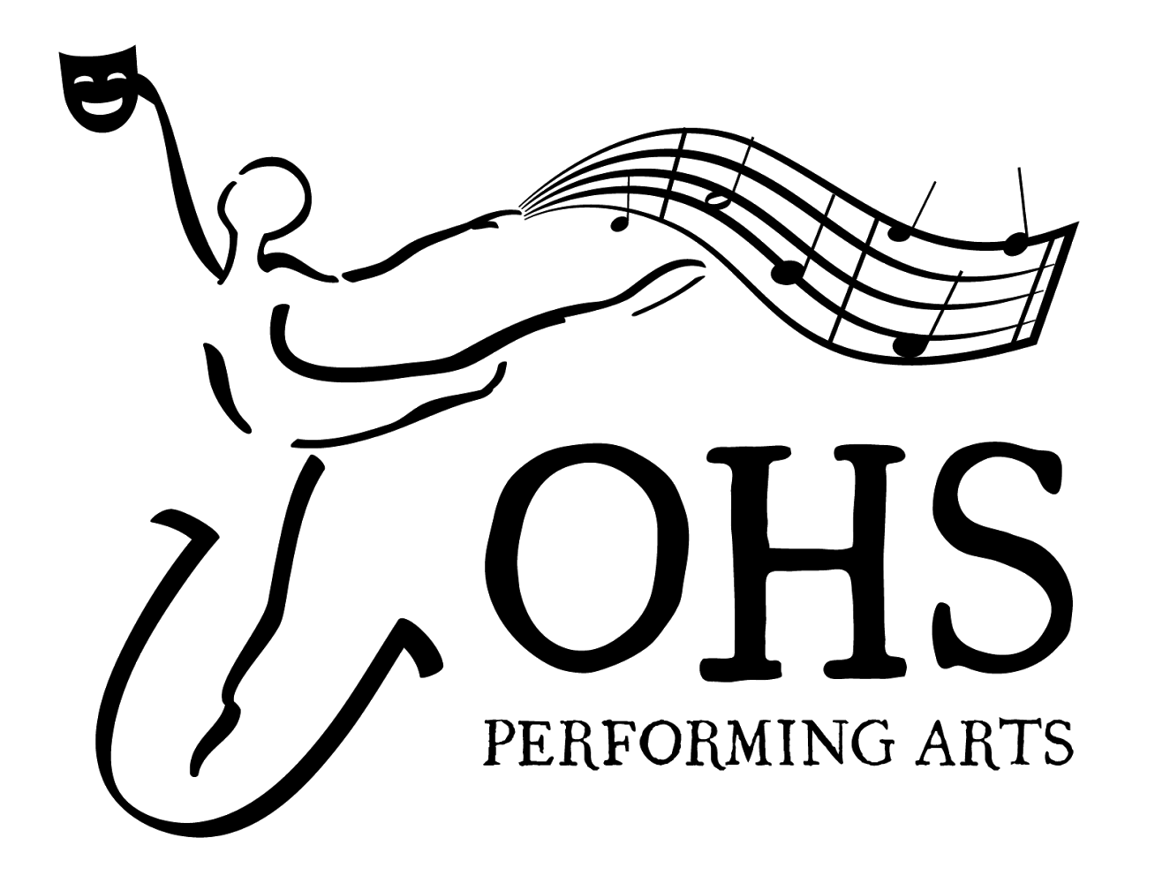
OHS Performing Arts Apparel Order Form
Name:__________________________________________________
Email:__________________________________________________
Phone:_________________________________________________
OHS Student’s Name:_____________________________________
Codes for Apparel Order Form
Style | Color | Logo Placement | Size
S - Short Sleeve ($10.00)  L - Long Sleeve ($15.00)  H - Hoodie ($25.00) | M - Maroon  G - Grey  B - Black | P - Left Pocket  C - Center Chest | S - Small  M - Medium  L - Large  XL - Extra Large

Fill out the order form below using the codes provided in the table above. Enter each item separately unless you plan to purchase duplicates of the same item. All logos will be printed in white ink (see image above).

Qty | Style | Color | Logo | Size | Price | Total

*Please make checks payable to Owen High School Total _________________

